主标题: rfid tablet
副标题：Y100-UHF Android Tablet RFID reader
Key features:
MT6789 (2 Arm) ® Cortex-A76 core, operating frequency of 2.2GHz, 6 Arm ® Cortex-A55 core, operating at a frequency of 2.0GHz
Android 16，Memory: 8G+128G Optional:8G+256G
10.1-inch resolution 800 * 1280, optional: 1200X1920
Built in Impinj E-series chip UHF RFID module with excellent reading performance.
Barcode, QR code scanning
4G communication, dual band Wi Fi, and Bluetooth for seamless connectivity

rfid tablet-1
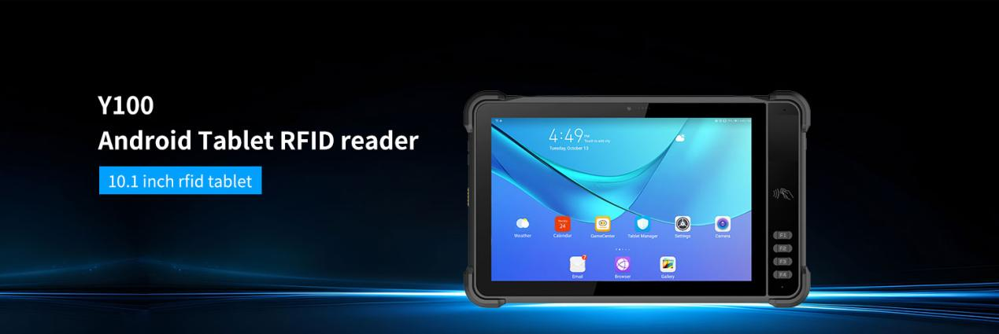
The Y100 RFID tablet is equipped with a high-performance 8-core 2.2GHz CPU, Android 13 operating system, and standard 8G+128G memory, providing faster and more stable operation. Integrated with the industry's best UHF RFID module based on Impinj E-series chip, it has excellent RFID tag reading and writing performance. 10.1-inch high-definition display screen, supporting multi touch and glove touch. Built in 10000mAh large capacity battery, with stronger endurance, can meet long-term work needs. IP67 waterproof and dustproof, the body is made of high-strength industrial materials, sturdy and durable. This RFID enabled tablet can perform various tasks in retail operations, inventory management, logistics, asset management, and other fields.
Optional features: barcode scanning, NFC reading and writing, fingerprint recognition, and other functions.

rfid tablet-2
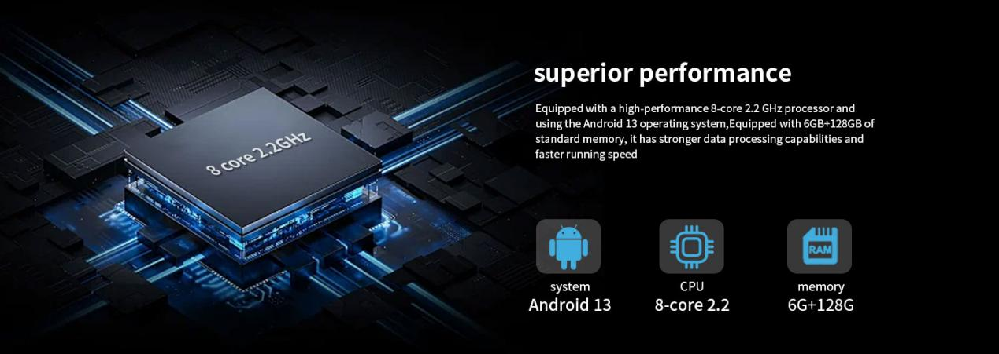
Hardcore configuration
High performance 8-core 2.2GHz processor, Android 16 operating system, 8GB+128GB memory, faster and more stable running speed
rfid tablet-3
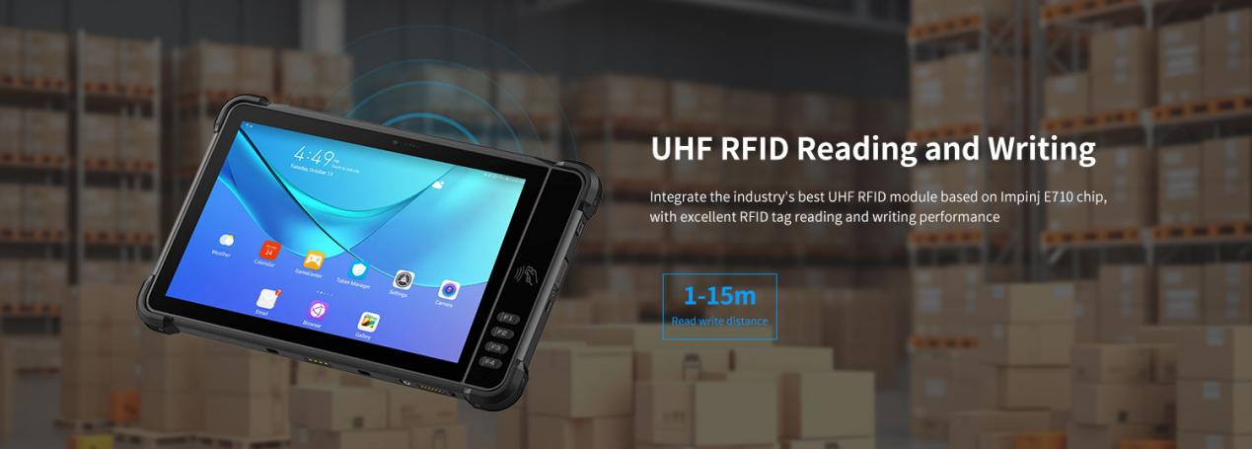
Ultra high frequency RFID reading and writing
rfid tablet Built in Impinj E-series chip UHF RFID module with excellent reading performance. It can efficiently, quickly, and accurately identify popular electronic tags in the market. Can perform various tasks in retail operations, inventory management, logistics, asset management, and other fields.
RFID module optional:
module based on lmpinjE710
module based on lmpinj E510
module based on lmpinj indy R2000
Operating frequency:
North America: 902-928MHz FCC (NA, SA)
Europe: 865-868MHz (ETSI)
China: 920-925MHz (CMIIT)
Full frequency range: 860-960MHz (OPEN)
Protocol: EPC global UHF Class 1 Gen 2 (ISO 18000-6C)
Antenna：Circular polarization, 4dBi
Power：1W(30dBm, +5dBm to +30dBm adjustable)
2W Optional ( 33dBm, for Latin America, etc.)
Max Read Range：Up to 15 m (open outdoors, lmpinj MR6 tag)
Fastest Read Rate：150+tags/sec
rfid tablet-4
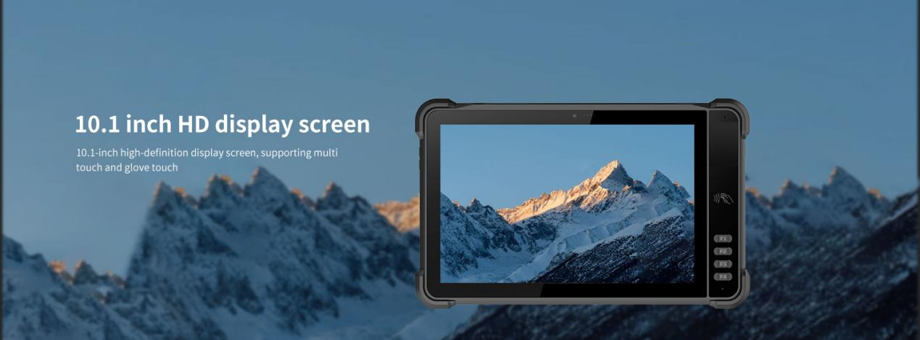
10.1-inch high-definition large screen
High resolution 1920x1200, with clear and delicate images. The high brightness screen (700nits) can maintain clear visibility even under strong light, allowing outdoor workers to not worry about light interference and ensuring bright and clear visual effects in various environments.
Paired with sensitive 10 point touch technology, the operation is smooth and natural. Whether it's clicking, sliding, or zooming, it can respond quickly, bringing users an efficient and convenient operating experience.

rfid tablet-5
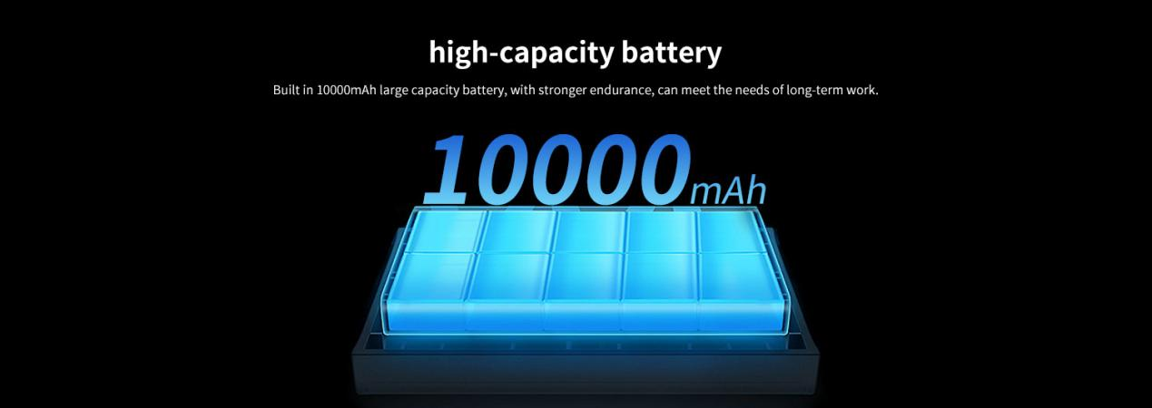
Ultra long battery life, say goodbye to power outage anxiety
Built in 10000mAh high-capacity polymer lithium battery, it can easily cover all day long even for heavy outdoor work.
Supports Type-C 30W PD fast charging technology, which can replenish core power in 2-3 hours, and is equipped with four layers of safety protection: overcharge, overdischarge, short circuit, and overheating.
NFC short-range communication
rfid tablet Built in NFC proximity sensing recognition chip, sensing card and point-to-point communication function, supports ISO14443A/B protocol, card reading distance 1-3cm
rfid tablet-6
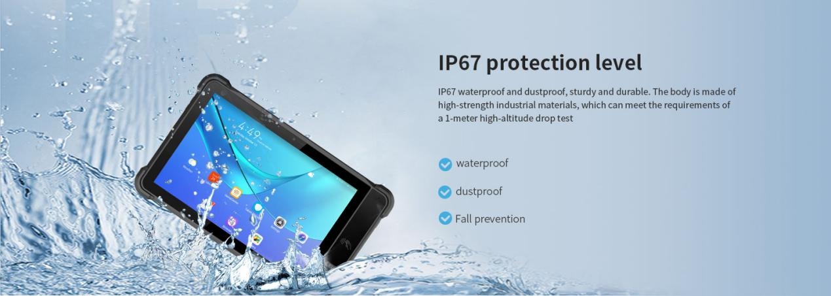
Protection level
IP67 dustproof and waterproof; The body is made of high-strength industrial materials, which are sturdy and durable, and can meet the requirements of a 1-meter high-altitude drop test. The four corners of the tablet are designed with protective angles, effectively reducing impact injuries.
Provide ODM and OEM customized services
• We work closely with our partners and can provide various one-stop customized solutions.
• Appearance customization: supports customization of product nameplates, product packaging, and promotional materials.
• Hardware customization: Supports customization of functional modules and optional hardware functions.
• Software customization: supports customization of boot interface, boot program, kernel clipping, and API interface.
• Technical support: Provide SDK development kits and application software development technical services.

HARDWARE CUSTOMIZATION
1: Nameplate Logo Customization
2:Packaging Custom Design
﻿
SOFTWARE CUSTOMIZATION
1:Boot Screen Customization
2:System Function Hiding
3:Built-in Customer App
4:Customer App Auto-launch
5:Platform Software Integration
6:Fixed MAC Address
7:Download Prohibition
﻿8:USB Disablement
﻿9:APP Installation and Uninstallation Control
10:Pre-installed APK
﻿11:Camera Control
12:Provide System Signing Files

frequently asked questions
Q: Are you the original manufacturer?

A: Yes, we are the original manufacturer. We have our own brand LQYCIT. All of our products have complete patented ID/MD designs, hardware and software, molds, and assembly are all completed by our own team.

Q: Can you pre install our software?

A: Yes, we can pre install your software.

Q: What is the minimum order quantity?

A: We accept standard product orders starting from one unit. If necessary, we can even customize your logo. For OEM, our sales team will review the detailed requirements and confirm the minimum order quantity.

Q: Can we get free samples?

A: Sorry, we usually do not provide free samples. If the customer confirms the specifications and pricing, they can first order samples for testing and evaluation.

Q: How to place an order and make payment?

A: We accept wire transfers (bank transfers), Alibaba online payments, and Western Union remittances.

Q: What is the warranty period for your products?

A: We offer a 12-month warranty after shipment.

Q: How long is the delivery time?

A: The production delivery cycle is about 3-10 days, depending on the requirements. The delivery time through DHL/UPS/FedEx/TNT is approximately 3-5 working days. For some remote areas, the transportation time may be longer.

Q: How to fix equipment problems?

A: We will provide online technical support to solve problems. For hardware issues, we can ship parts or components for customers to install (if they have technicians), or we can ship them back to us for repairs.

